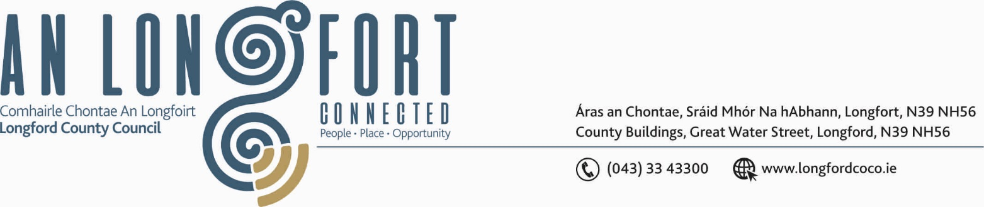

LONGFORD MUNICIPAL DISTRICT

Please note meeting will be held via Microsoft Teams.

21st January 2020.

To: Each Member of Longford Municipal District.

Dear Member,

You are requested to attend Meeting of Longford Municipal District to be held
via Microsoft Teams on Wednesday, 27th January 2021 4.30 p.m. to transact business, as set out on the Agenda hereunder.

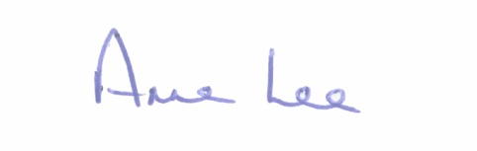
Yours sincerely,

_______________
Anne Lee,
Meetings Administrator.

AGENDA

Prayer before meeting.

- Confirmation of Minutes of meeting of Longford Municipal District held on
the 25th November 2020 - copy enclosed

- Matters arising from Minutes.

- Declaration of Interest by Members.

- Management Report – to follow.

- Consideration and adoption of Draft Municipal District Report for inclusion in
Longford County Council 2020 Annual Report – enclosed.

- Request received from The Irish Cancer Society to light up landmarks and public buildings yellow on the 26th March 2021 - Annual Daffodil Day – to heighten awareness of Daffodil Day Campaign – correspondence enclosed.

- Consideration of the Taking in Charge of Radharc na Choille, Cullyfad, Co. Longford – report enclosed.

- Notices of Motions, submitted by Councillors, as listed hereunder –

Councillor John Browne.

“Householders at Madeira Gardens off the Dublin Road are encountering serious difficulties from sewage overflows in their back gardens. I urgently call on Longford County Council, together with Irish Water to deal with the problem”

Councillor Seamus Butler.

‘That we agree a programme to complete the balance of the renovation of the footpaths in Teffia Park’

Councillor Uruemu Adejinmi.

“I am calling on the County Council to place double yellow lines along Dublin Road opposite St Joseph’s National School prohibiting parents/guardians from parking their cars across the road and on the footpaths. This will help ensure cars are parked in the designated parking areas and children taken to the pedestrian crossing to keep children safe and road free of obstruction.”

“I am calling on the Council to add a pedestrian crossing at St Michael’s Boys National School for safe crossing of children during drop off and pick up.”

Councillor Gerry Hagan.

“Road Safety Measure - I call on Longford MD to install Flashing Speed Sign at Fisherstown, Clondra, on approach road to Tarmonbarry.”

“Road Safety Measure - That Longford MD will grit and salt the Knockloughlin Road between Kiernans Forge and Melview Crossroads. This road has been the scene of five car accidents during the recent frosty period since Christmas.”

“Footpath Development –
- Completion of footpath at Foynes Court to join up with the Footpath on the Knockmartin Lane.
- Extension of the Footpath from Abbott Laboratory to Carriglass Roundabout. This is a densely populated area, with a large numbers of people walking along this very busy and dangerous stretch of road.”

